India tour 14-30 November 2018
Hotels day 6 stay for two nights
Itinerary:-
From the Anglican Tours India tour booklet the hotel listed for the days 6 and 7 is as follows:-
Day 6 and 7 – Jaisalmer, located in the far west of Rajasthan, hotel Fort Rajwada, Jodhpur Barmer Link Road Jaisalmer.
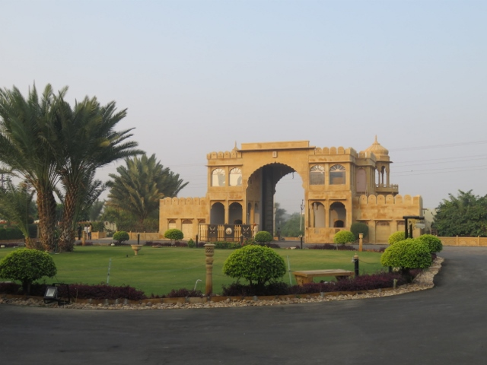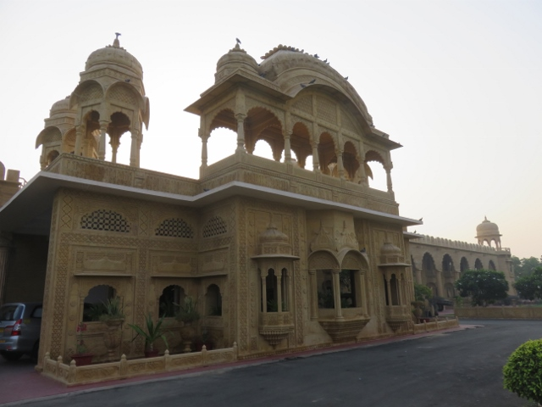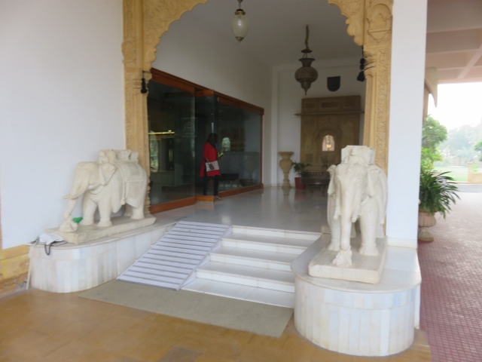
Hotel Fort Rajwada entrance gate. Hotel main entrance concourse. Marble elephants guarding entrance.
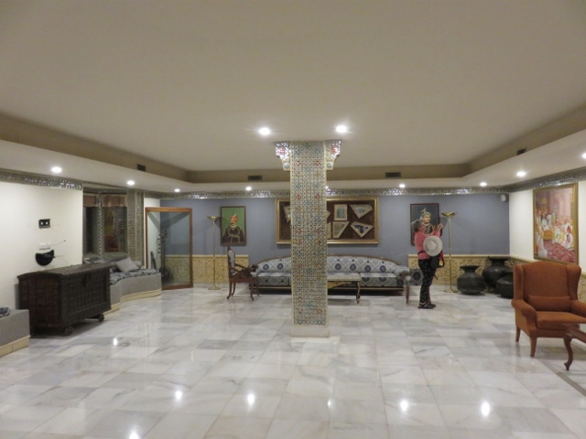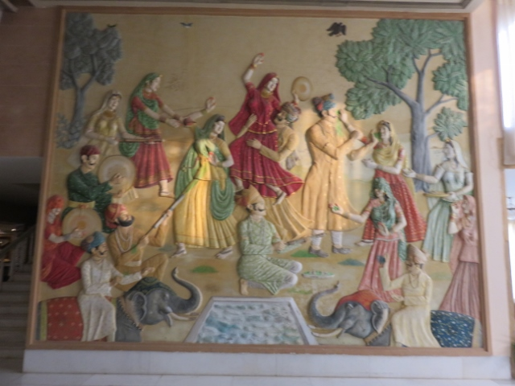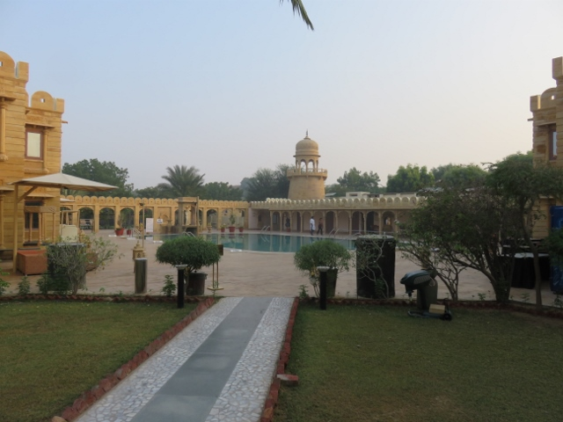
Hotel lobby area note the marble tiles. Murial on wall in lobby Hotel swimming pool
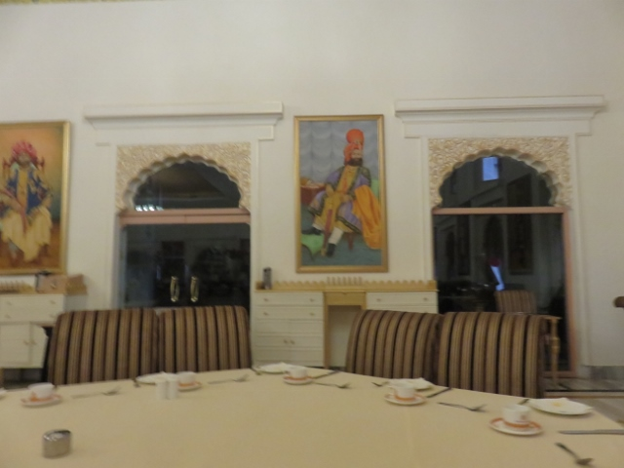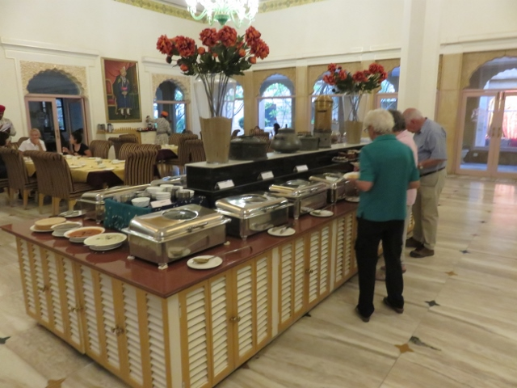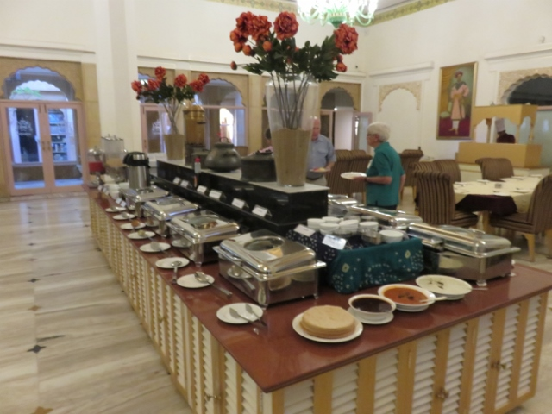
Hotel dining room round table. Self serve buffet side 1 self serve buffet side 2
This hotel was another step up in the comfort area, with large lawns and gardens and enormous bedrooms for guests.
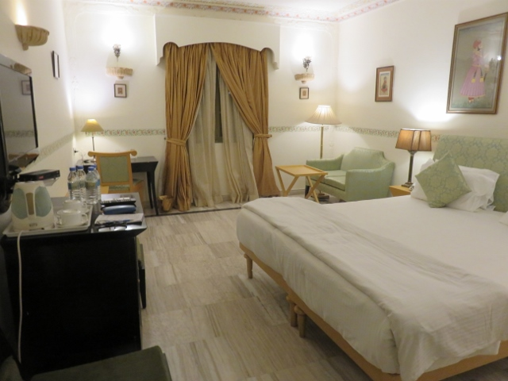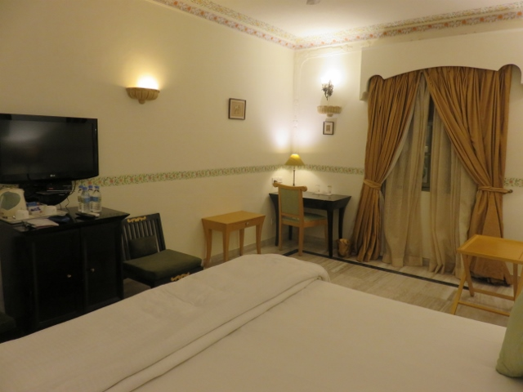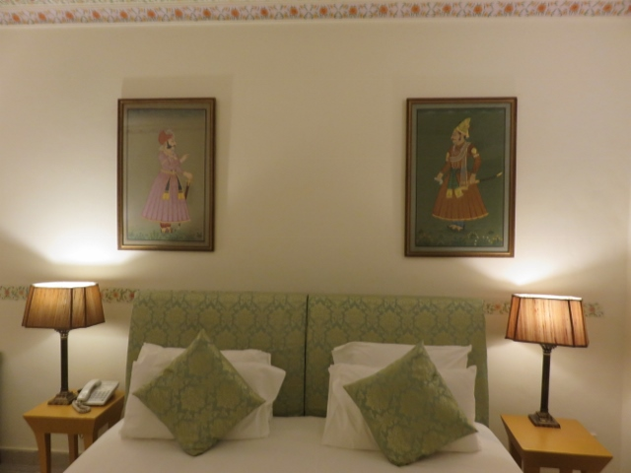
Alan’s room 116 plenty of room to move around special paintings on wall behind bed.
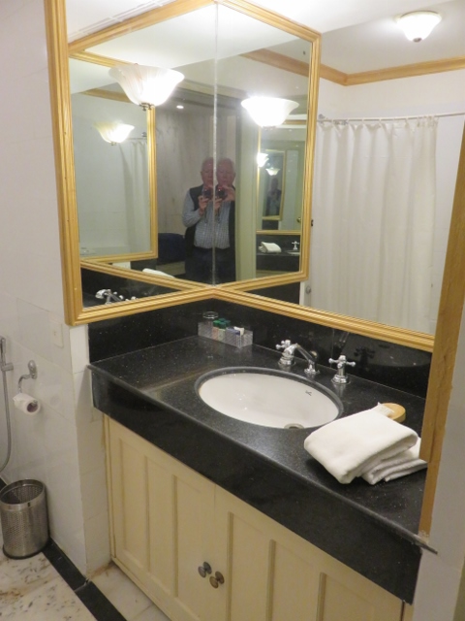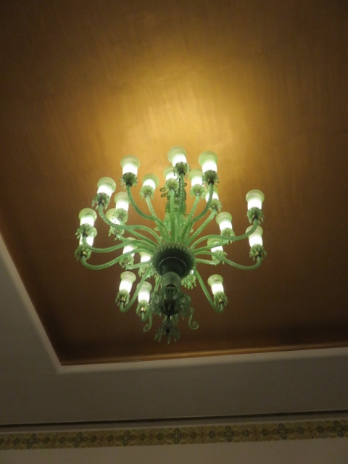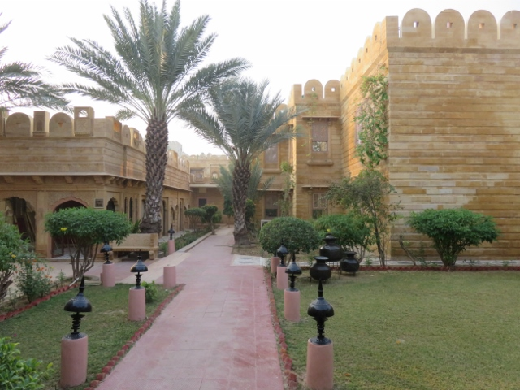
Alan’s bathroom in 116. Green chandlers in dining room Fort style apartment blocks
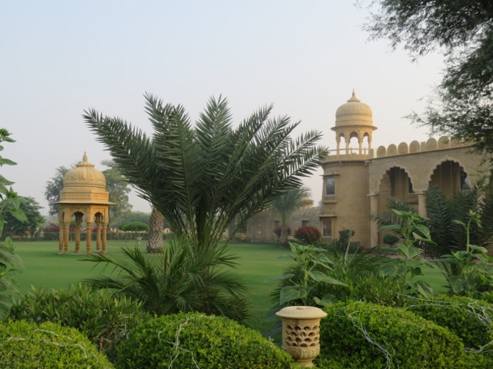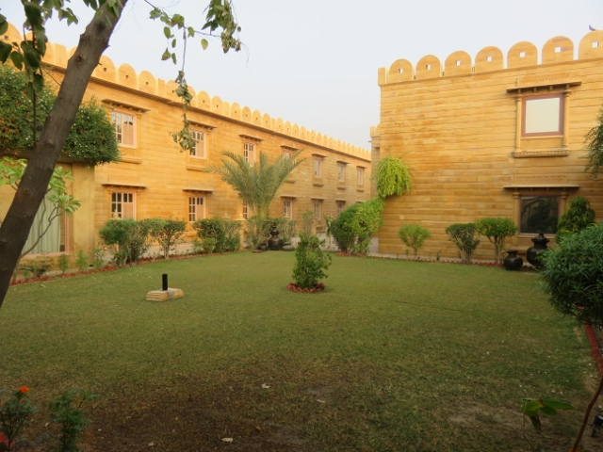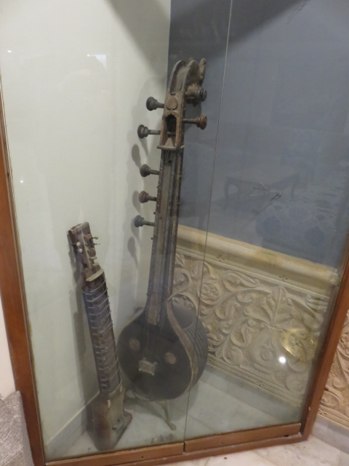
Another view of lawns at entrance. Internal lawns between accommodation blocks. String instrument display.
The hotel is named as a Fort and its architecture certainly gives that impression. The grounds are enormous and the space for rooms, dining areas, swimming pools etc are huge. The buffet meals had a wide variety of western and Asian foods to choose from. The tour was scheduled to stay here for 2 nights to enable the group to see all the adjacent sights. There is also an Indian Airforce base nearby with a constant noise of supersonic jets doing manoeuvres overhead. No doubt to keep the Pakistani forces and their radar units on their toes just across the border from India.

